HTML TASK – 28-11-2025
TASK 1 – CSS Grid Layout Demo
index.html
<!DOCTYPE html>
<html lang="en">
<head>
<meta charset="UTF-8">
<meta name="viewport" content="width=device-width, initial-scale=1.0">
<title>CSS Grid Layout Demo</title>
<link rel="stylesheet" href="style5.css">
</head>
<body>

<div class="grid-container">
<div class="grid-item">1</div>
<div class="grid-item">2</div>
<div class="grid-item">3</div>
<div class="grid-item">4</div>
<div class="grid-item">5</div>
<div class="grid-item">6</div>
<div class="grid-item">7</div>
<div class="grid-item">8</div>
<div class="grid-item span-item">Call to Action</div>
</div>

</body>
</html>
style5.css
.grid-container {
display: grid;
grid-template-columns: repeat(3, 1fr);
grid-gap: 15px;
width: 90%;
margin: 50px auto;
}

.grid-item {
background-color: #AEC6CF;
color: #333;
padding: 20px;
border-radius: 5px;
min-height: 100px;
text-align: center;
font-size: 1.5em;
}

.span-item {
background-color: #FF6961; /* Salmon Red */
grid-column: 1 / 4;
font-weight: bold;
color: white;
}
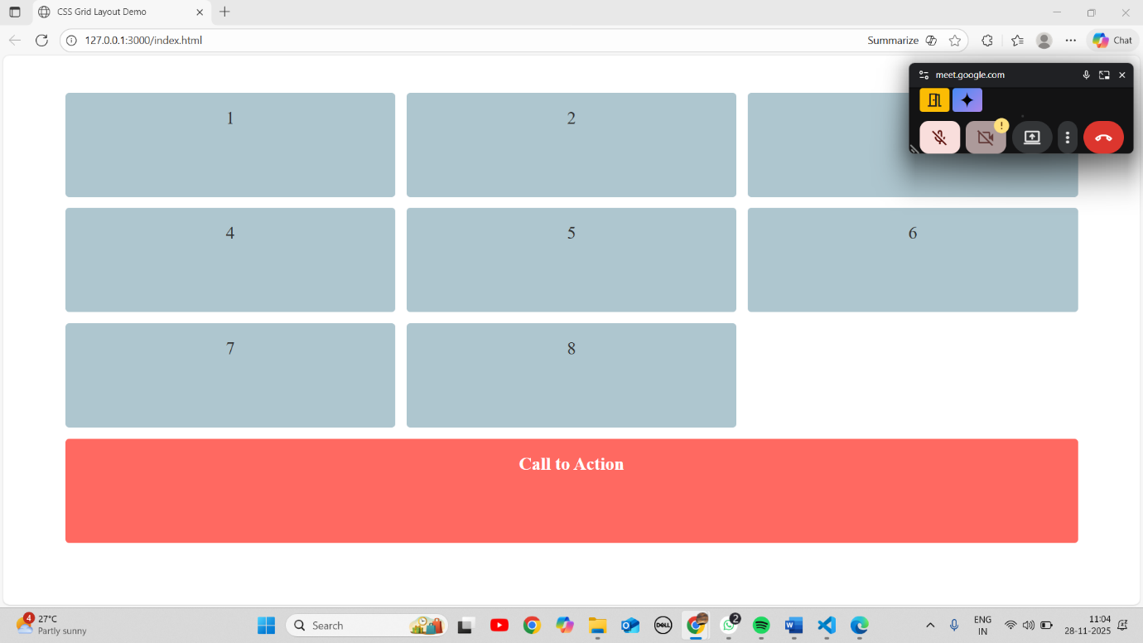

TASK 2 – HTML5 Validation Demo
index.html
<!DOCTYPE html>
<html lang="en">
<head>
<meta charset="UTF-8">
<meta name="viewport" content="width=device-width, initial-scale=1.0">
<title>HTML5 Validation Demo</title>
<link rel="stylesheet" href="style6.css">
</head>
<body>
<form action="#" method="POST">
<h2>User Login</h2>

<label for="username">Username (Min 6 chars):</label>
<input type="text" id="username" name="username" minlength="6"><br><br>

<label for="password">Password (*Required):</label>
<input type="password" id="password" name="password" required><br><br>

<button type="submit">Log In</button>
</form>
</body>
</html>
style6.css
input:valid:focus,
input:valid {
border: 1px solid #000000;
}

input:invalid:focus {
border-color: #FF0000;
box-shadow: 0 0 5px rgba(255, 0, 0, 0.5);
}

input {
padding: 8px;
margin-top: 5px;
width: 250px;
box-sizing: border-box;
}
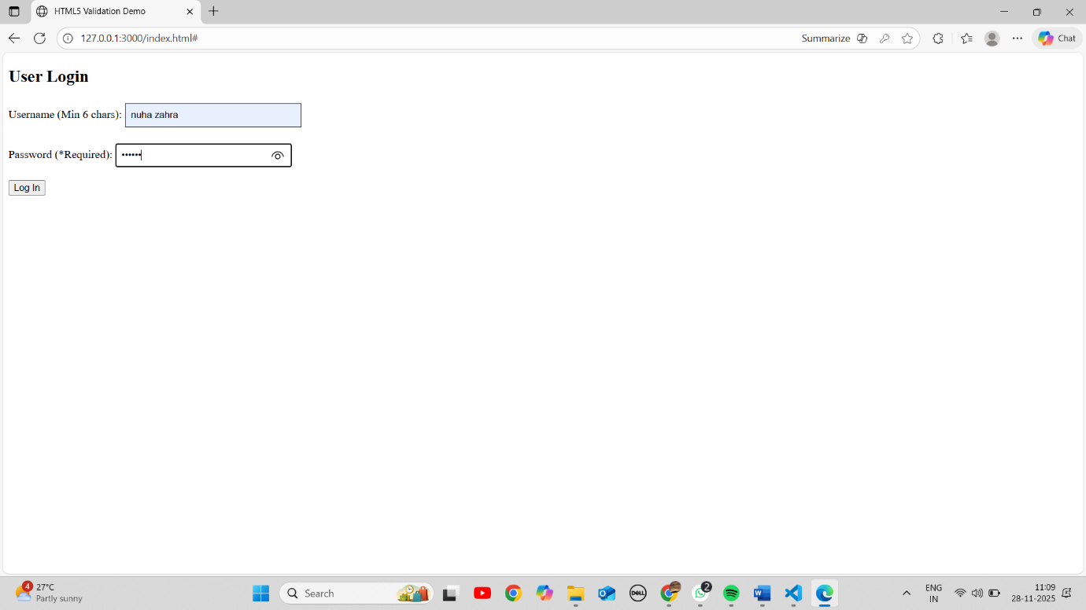

TASK 3 – Navigation Bar Styling
index.html
<!DOCTYPE html>
<html lang="en">
<head>
<meta charset="UTF-8">
<meta name="viewport" content="width=device-width, initial-scale=1.0">
<title>Navigation Bar Styling</title>
<link rel="stylesheet" href="style3.css">
</head>
<body>
<nav>
<ul class="nav-menu">
<li class="nav-item active"><a href="#">Home</a></li>
<li class="nav-item"><a href="#">About</a></li>
<li class="nav-item"><a href="#">Services</a></li>
<li class="nav-item"><a href="#">Contact</a></li>
</ul>
</nav>
</body>
</html>
style3.css
.nav-menu {
list-style-type: none;
padding: 0;
margin: 0;
background-color: #333;
}

.nav-item {
display: inline-block;
}

.nav-item a {
display: block;
color: white;
text-align: center;
padding: 14px 16px;
text-decoration: none;
}

.nav-item.active {
background-color: #007BFF;
color: white;
}
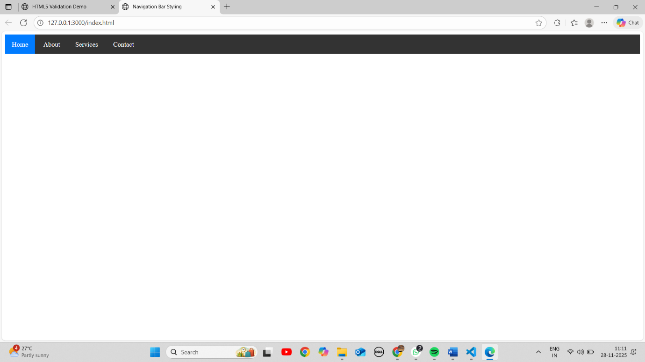

TASK 4 – Theme Switcher Demo
index.html
<!DOCTYPE html>
<html lang="en">
<head>
<meta charset="UTF-8">
<meta name="viewport" content="width=device-width, initial-scale=1.0">
<title>Theme Switcher Demo</title>
<link rel="stylesheet" href="style2.css">
</head>
<body>
<button id="themeToggle">Toggle Theme</button>
<div class="container">
<h2>Theme Demonstration</h2>
<p>This paragraph demonstrates the style change between themes.</p>
</div>
</body>
</html>
style2.css
body {
background-color: white; /* Light mode default */
color: black;
transition: 0.3s ease;
}

body.dark-theme {
background-color: #282c34;
color: #f2f2f2;
}

body.dark-theme .container {
border: 2px solid #5C6773;
}

.container {
max-width: 800px;
margin: 50px auto;
padding: 20px;
}
